**Luke Pepin - The Sea Around Us**

**Homework Assignment 3**

**DUE: Tuesday, October 8, 2024**

1. Provide a depth profile of your Favorite Sea. Search this information and describe the basic bottom topography in words and also provide a figure. Provide a citation for the figure by simply copying and pasting the website it was copied from. Paste the website name below the figure.

My favorite sea chosen during the first assignment is the Mediterranean Sea. The average depth of this sea is 1500 meters. The deepest point of the Mediterranean Sea is the Calypso Deep, Ionian Sea around 5300 meters deep. The Mediterranean’s large size means its topography varies greatly. As a result it is composed of many smaller seas such as the Alboran, Ligurian, Tyrrhenian, Adriatic, Ionian, and Aegean seas. For oceanographic purposes, the sea is most commonly divided into two main basins: the western and eastern basins, separated by the (relatively) shallow Sicily Strait.

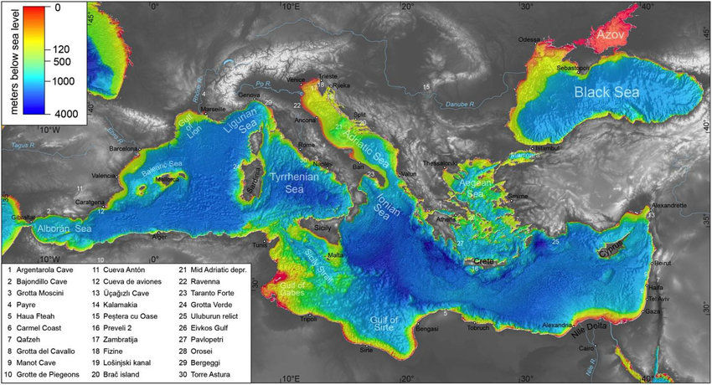*Fig 1:* [*A topographic map of the Mediterranean Sea region with bathymetric data... | Download Scientific Diagram (researchgate.net)*](https://www.researchgate.net/figure/A-topographic-map-of-the-Mediterranean-Sea-region-with-bathymetric-data-derived-from-the_fig11_318588941)

1. Detail the salinity and temperature range of your favorite sea.

The Mediterranean Sea is known for its high salinity, averaging around 38 ppt. In the eastern basin during summer, salinity can reach as high as 40 ppt. Compared to the average sea salinity of 35 ppt. Its high salinity is due to high amounts of evaporation and limited riverflow into the sea.

The temperature range of the sea varies significantly throughout the year. Due to the Mediterranean being semi-enclosed, the sea has exteme temperature changes over the course of the year. In winter, it can reach around 15°C (59°F), while in summer it can reach up to 26°C (79°F).

1. Lastly, identify and describe 5 species of marine organisms that live in your sea. These can be any type of life form. Provide the common and scientific names, and general phylum (use the info in Ch. 4 and the internet to assist you). You may provide pics if desired.

The general phylum of all five of this marine organisms is Chordata.

1. Mediterranean Monk Seal (*Monachus monachus*) - One of the most endangered marine mammals in the world due to hunting, human distrubance and climate change. They are typically found on secluded beaches or sea caves.
2. Fin Whale (*Balaenoptera physalus*) - The second largest whale species, known for its ridge along its back behind its dorsal fin. They often eat large schools of krill and other small fish at once.

1. Risso’s Dolphin (*Grampus griseus*) - With their large heads, they are playful and social creatures that inhabit deeper waters. They were named after Antonie Risso whose study formed the basis of recognition.
2. Loggerhead Turtles (*Caretta caretta*) - Turtles known for their large heads which support their powerful jaws that allow them to feed on hard-shelled prey. These are the turtles which are often seen laying eggs on the beach.
3. Mediterranean Pufferfish (*Lagocephalus sceleratus*) - The silver-cheeked toadfish, notable for the ability to inflate itself when threatened. They are an invasive species to the Mediterrranean and highly poisonous to eat, making life dificult for fisherman in the sea.